**Web Project Publish**

**Ques1:What is the role of IIS and how IIS Server works? Please describe properly about working with proper steps and explain Architecture. - 1 mark**

**Answer:**

IIS stands for Internet Information Services to publish the application on windows platform. It has a worker process which is the execution engine to handle request and response. Application pool and worker process are the two main components of iis server.Application Pool is a pool that contains a collection of applications in iis server. It container the w3wp.exe this is the work process which is the execution engine in iis server. Application pool contains the different collections of urls.Every application pool has a minimum one worker process. Any request sent for the application in that application pool. The worker process will handle the request and generate the response. One application pool can have more than one worker process.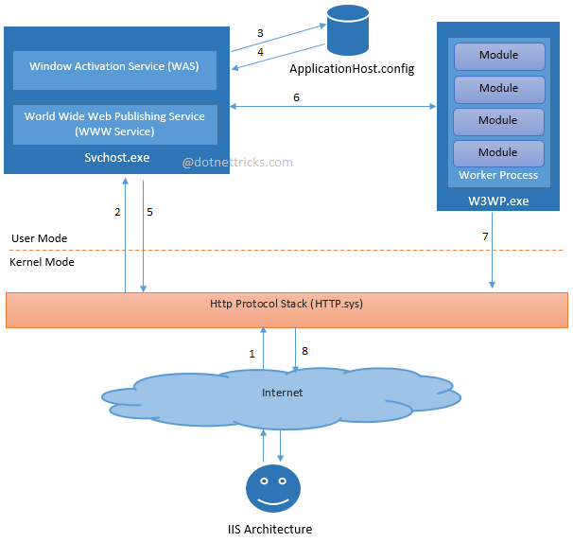

**Ques2:What is Application pool in IIS and how to create and assign Application pool to a website. Please explain in detail with example. - 1 mark**

**Answer:**

Application Pool is a pool that contains a collection of applications in iis server. It container the w3wp.exe this is the work process which is the execution engine in iis server. Application pool contains the different collections of urls.

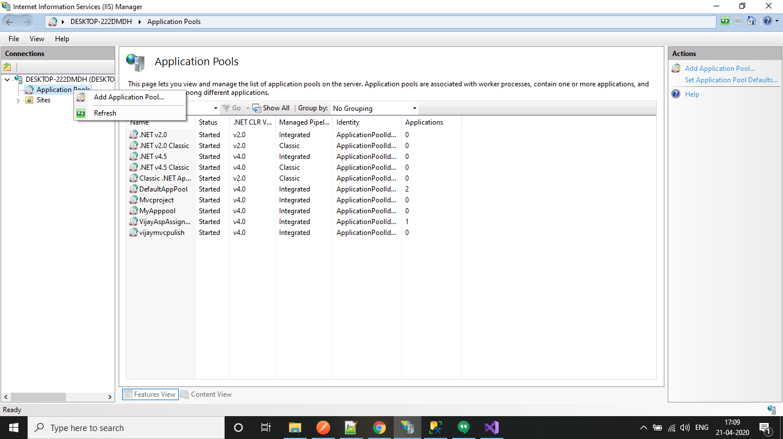

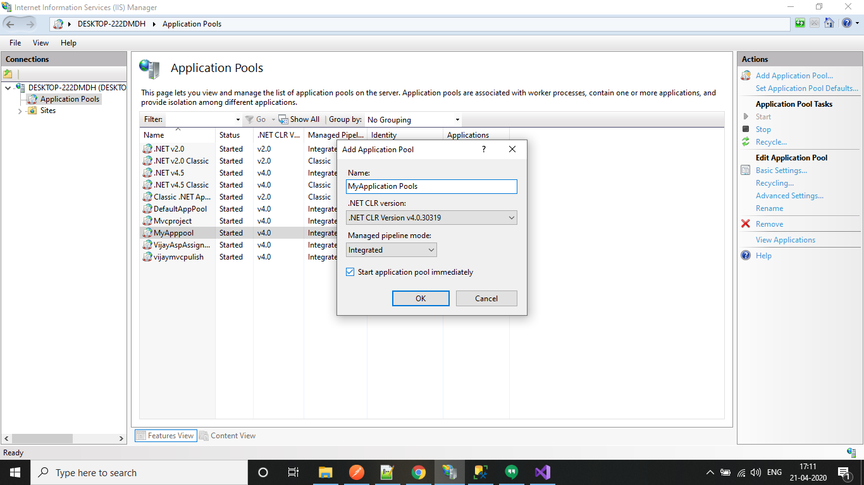

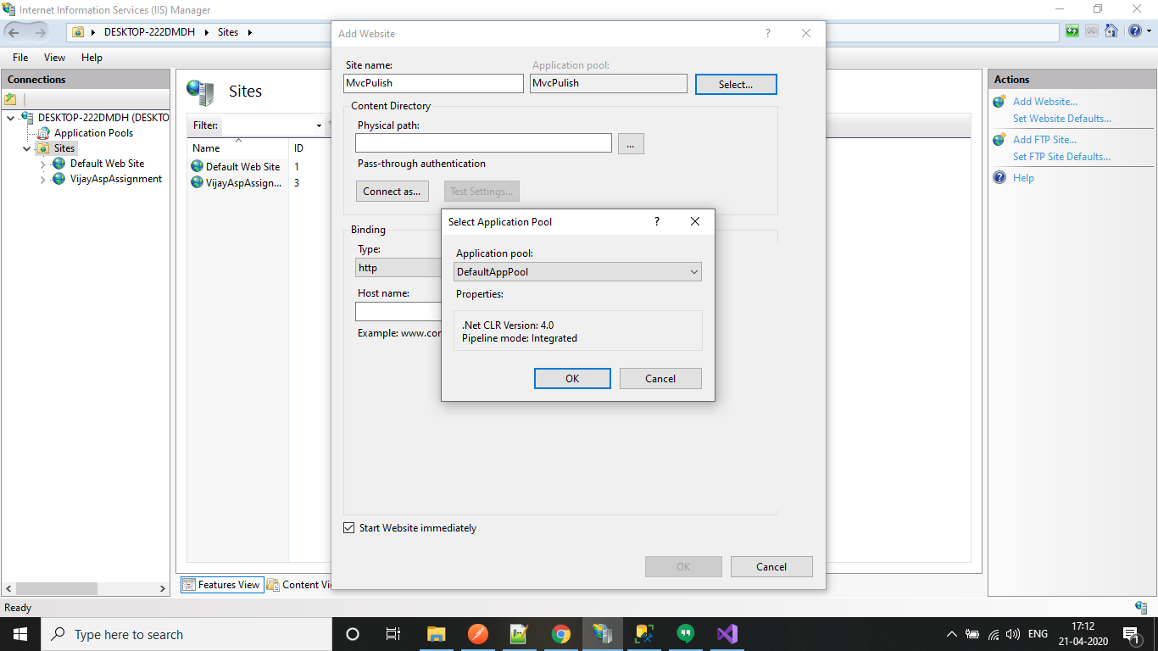

**Ques3:What are the different ways of deploying Asp .net application on IIS. Descibe briefly. - 1 mark**

**Answer:**

There are two ways of deploying an application that is local and global. In local deployment the entire application is in the virtual directory. All the configuration, assemblies and content in disk which are further available to the application. In global deployment the information of assemblies are available to the websites or applications that are running in the same server there is a common assembly for every application that is running in the same server. Whereas in local deployment every application has its own assembly associated with it.

**Ques4:What is virtual directory and what is its role? What Are The Execution Permission For Virtual Directory? Deploy website with Virtual Directory - 1 mark**

**Answer:**

Virtual directory in iis can be mapped to the physical directory at the local system. The name of the virtual directory is added in the url of the application. When a virtual directory receives the request it redirects it to the appropriate backend repository.

Below images

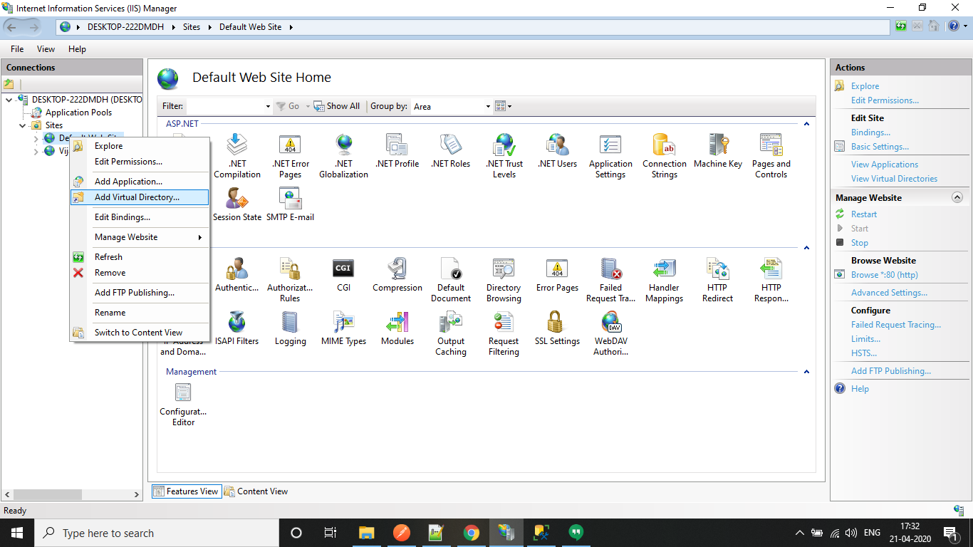

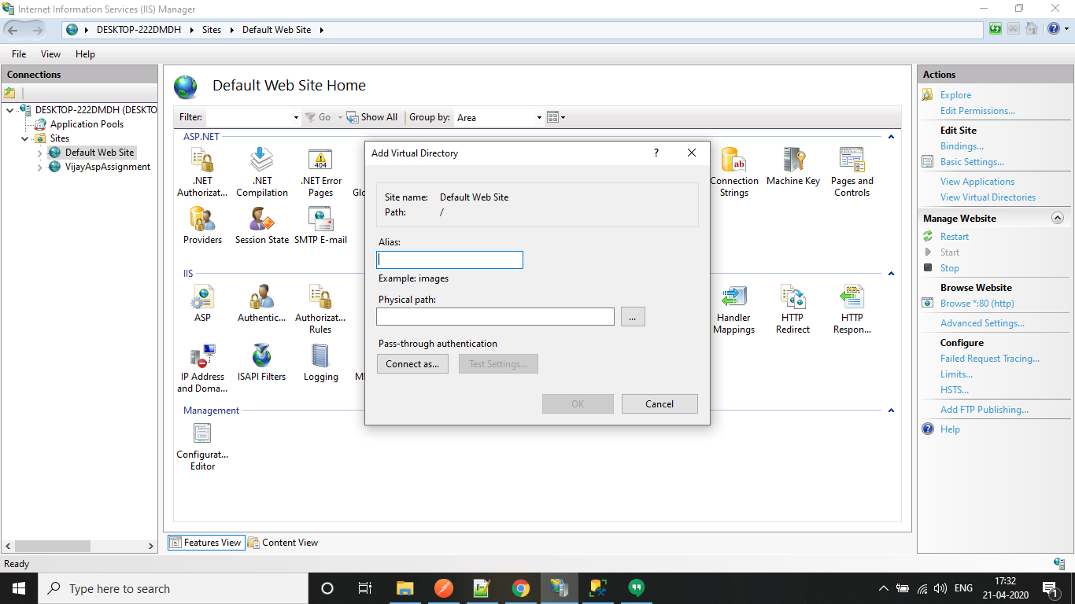

**Ques5:Create a asp .net core web application and deploy on the IIS Server by using hostName as of your name. Explain all the steps in document - 2 marks**

**Answer:**

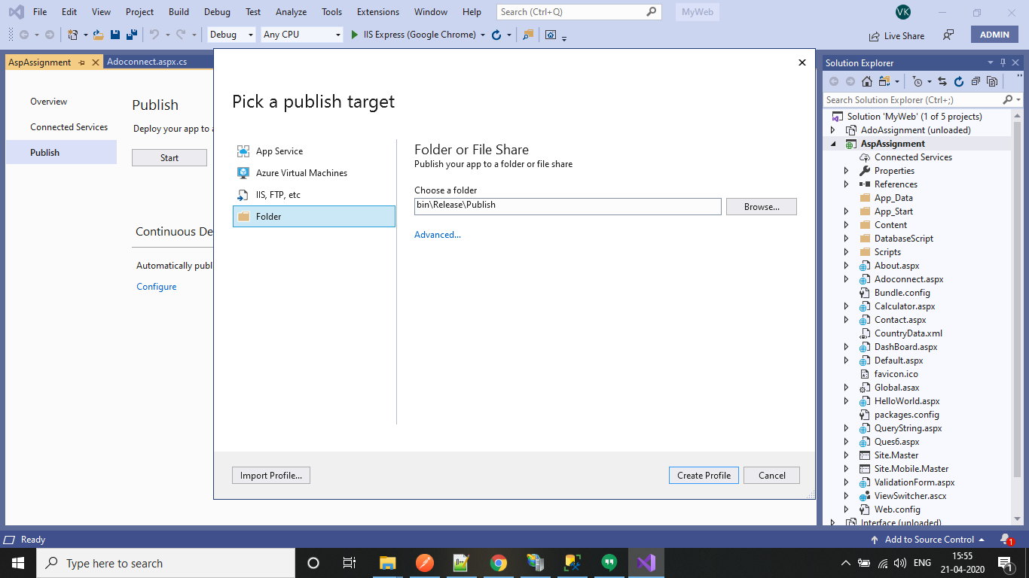

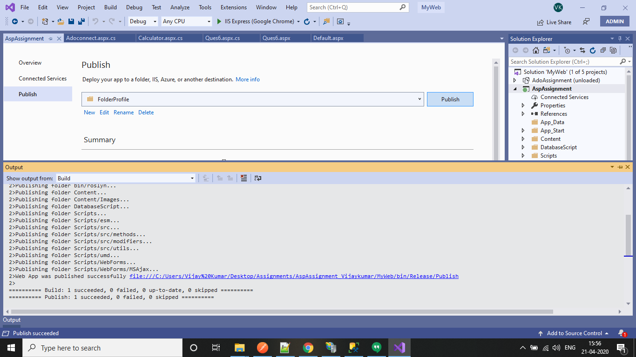

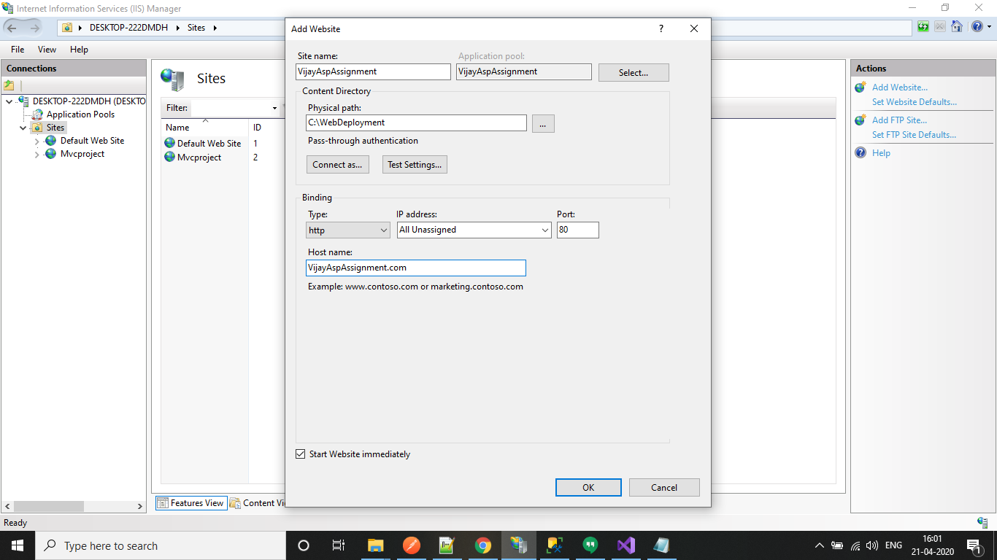

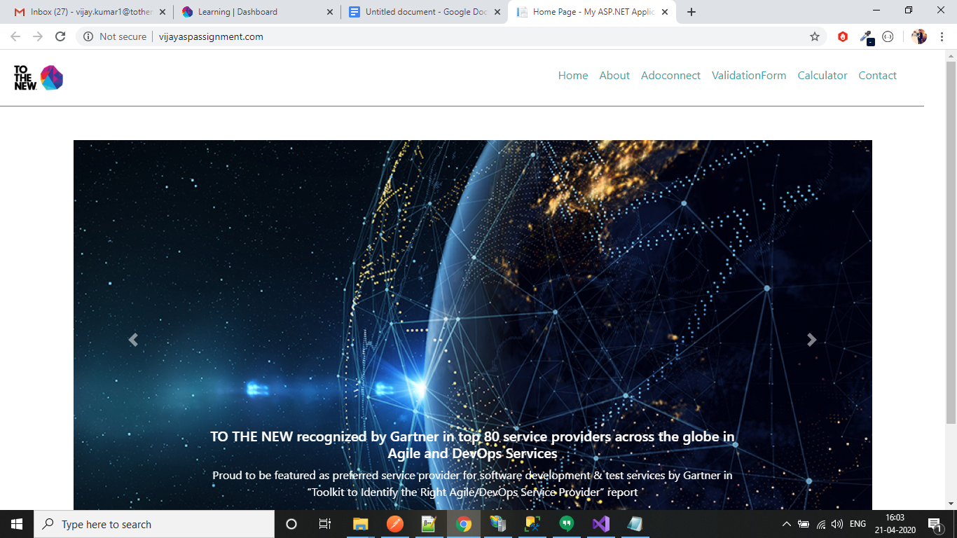

**Ques6:Deploy website using Web Deploy package OR Web Deploy with database. Explain the steps with explanations. - 2 marks**

**Answer:**

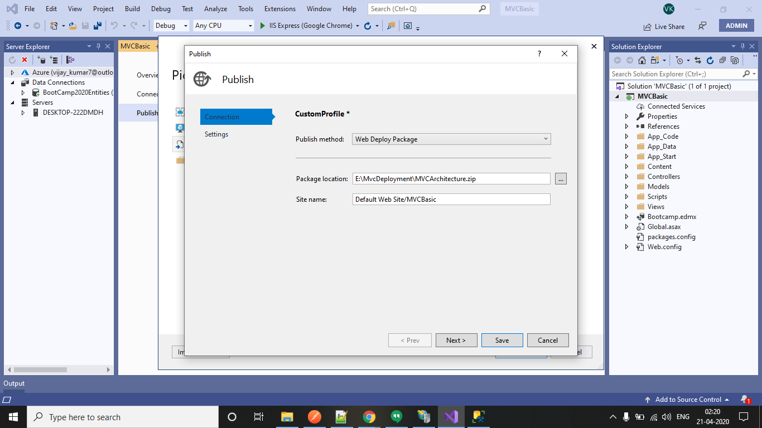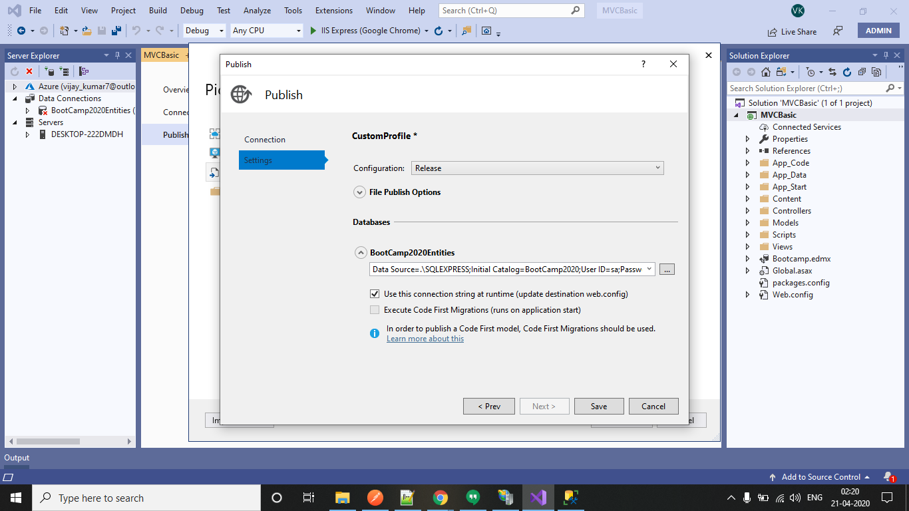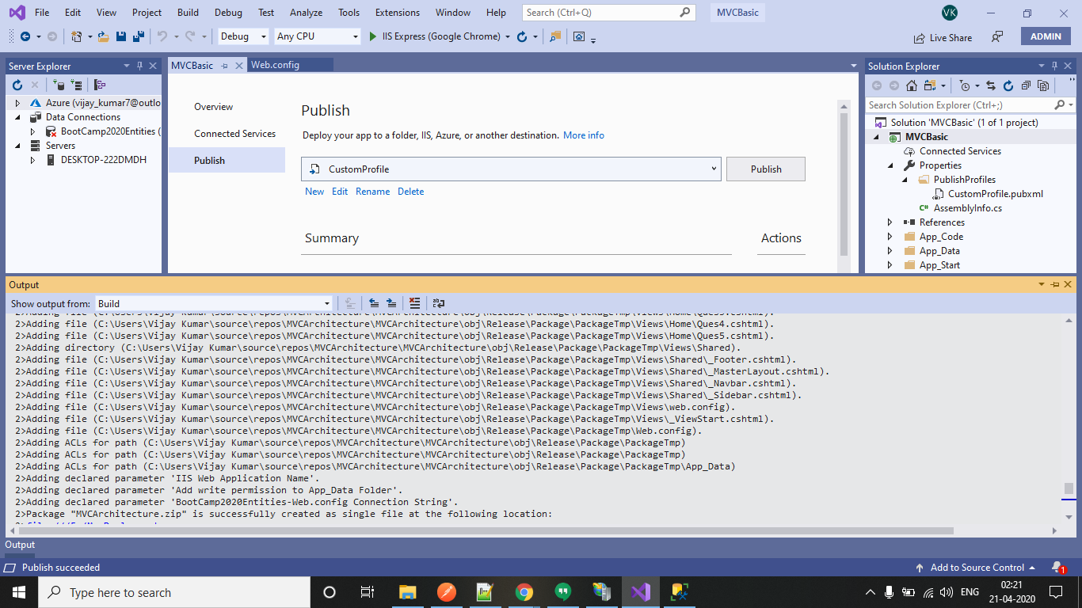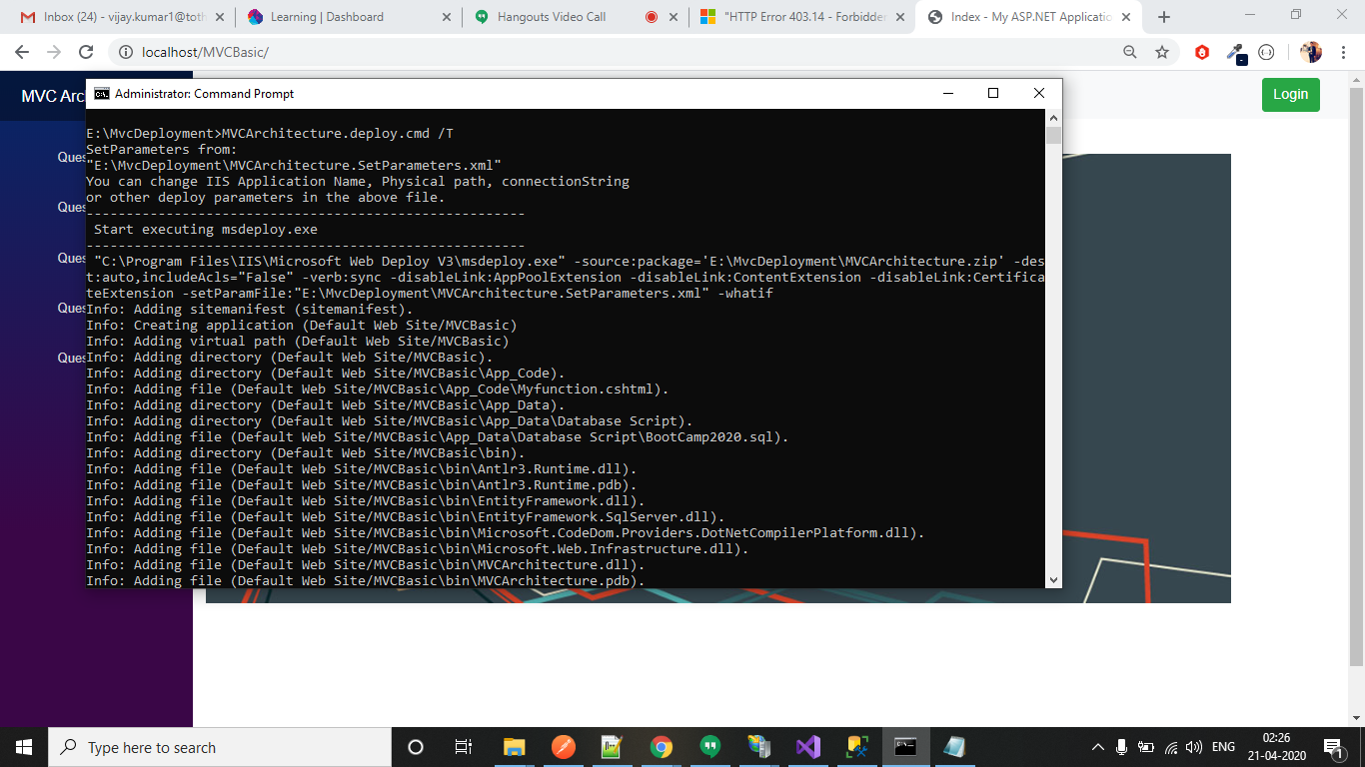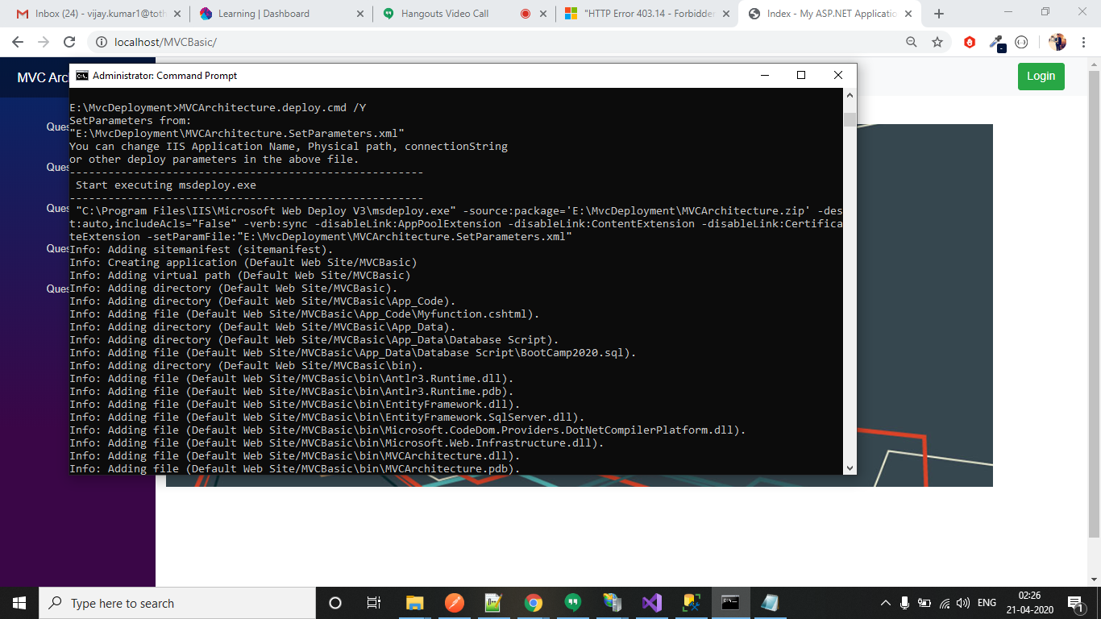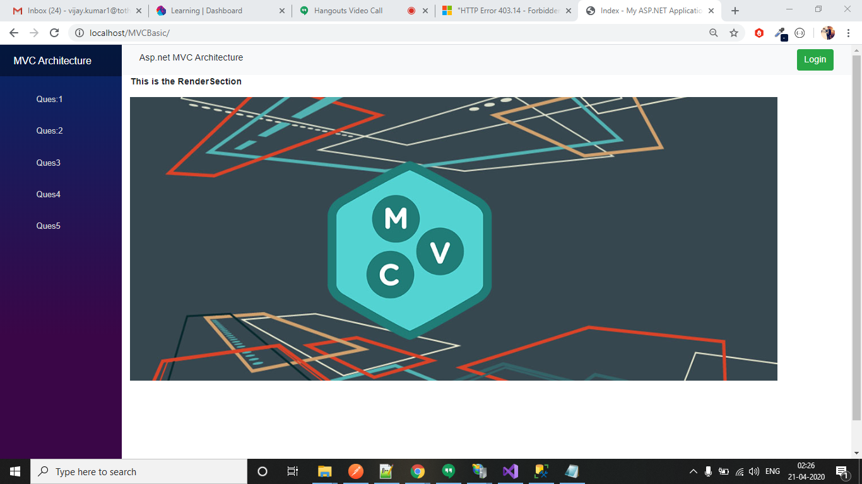

**Ques7:Deploy website using File system OR folder with SSL certificate. Explain all the steps in document - 2 marks**

**Answer:**